**1. In your own words, describe what the Internet of Things is and draw an illustration to show the main parts that make an IoT system. (4marks)**

The Internet of Things (IoT) is a system of interrelated computing devices, mechanical and digital machines, objects, animals or people that are provided with unique identifiers and the ability to transfer data over a network without requiring human-to-human or human-to-computer interaction.

The diagram below illustrates the major parts that make an IoT system

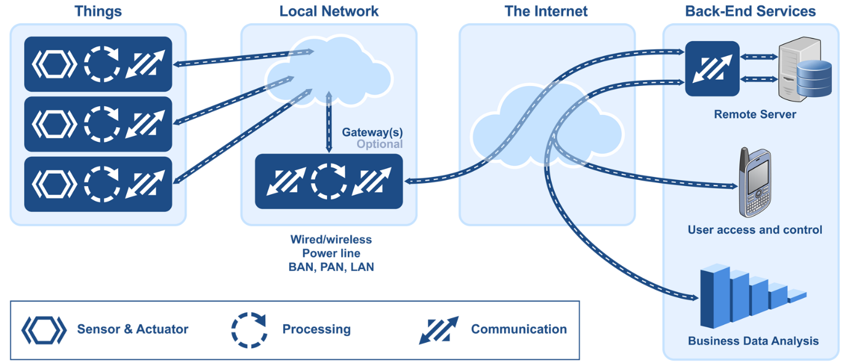

**2. Once an idea has been documented, what is the next step to be taken? (1mark)**

Prototyping is the next step in modelling and can cost a significant amount of money.

**3. Describe what you understand by interfacing and name 3 types of interfacing technologies (3marks)**

Interfacing is a term used in electronics when different electronic devices are connected in order to move information from one device to another.  This information may take the form of instructions for the function of a device, or feedback from a device about the results of executing a function.

Examples of Interfacing technologies include:

* Universal Asynchronous Receiver/Transmitter(UART)
* Serial Peripheral Interface(SPI)
* Inter-Integrated Circuit(I2C)

**4. What type of network device is used to forward packets from one network to other networks? (1mark)**

Routers are network devices that send packets from hosts on one network to another network.

**5.Cellular, Wi-Fi, Zigbee and Bluetooth are all ways you could communicate with your end devices wirelessly. Which two of these technologies require an IP-enables controller or gateway in order to gain indirect access to the internet? (2marks)**

Both the Bluetooth and Zigbee wireless technologies require devices that wish to communicate to establish a basic link prior to data exchange. This initial basic linking is called pairing. Wi-Fi and cellular communications do not require end device pairing.

**6. How are electronic sensors used in digitizing the natural world? (1mark)**

Electronic sensors are used to measure a physical event and translate it into an electrical signal. This digital signal can be received by a computer that is programmed to utilize this input.

**7. What is the purpose of an IP address? (1mark)**

Packets that are routed across the Internet contain source and destination IP addresses. These addresses are used to determine how the packets should be routed from source to destination by intermediate devices.

**8. Name at least 2 types of System on Chips(SoCs) you know (2marks)**

BeagleBone Black

Raspberry Pi

ESP8266

**9. What is an open-source physical computing platform that can take input from a variety of switches or sensors to control physical objects? (1mark)**

Arduino is an open-source physical computing platform based on a simple microcontroller board.

**10. A vibration sensor on an automated production line detects an unusual condition. The sensor communicates with a controller that automatically shuts down the line and activates an alarm. What type of communication does this scenario represent? (2marks)**

Scenarios in which sensors, RFID chips, and smart devices communicate with controllers or other smart devices and the communication results in activating a task based on the input from the sending devices are examples of machine-to-machine communication.

**11.True or False?**

**Traditional security devices such as firewalls and intrusion prevention systems will play a role in securing communications on the Internet of Everything. (1mark)**

Traditional security devices such as firewalls, intrusion detection systems, and intrusion prevention systems will all continue to have important security roles on the IoE.

**12.True or False?**

**Personal photos posted on social websites can be mined and used by marketers to promote products and services. (1mark)**

Once personal data is added to social websites, businesses and governments can gain access to that information and use it as they wish.

**13. Name 2 programming languages you can use to program end-devices (microcontrollers and SoCs) (2marks)**

**-**C/C++

-Python

**14. Fill in the blank.  
An employee who has an idea for a new product uses a 3D printer to create a fully functioning of the new product. (1mark)**

A prototype is a fully functional working version of a product. It is detailed enough that the prototype can be used for demonstration purposes, performance evaluation, and further improvement of the product.

**15. How do analytical tools help organizations model IoT solutions? (2marks)**

The IoE generates enormous amounts of data. This data must be processed so that it can be applied by an organization. To process data, several types of analytics are used to determine statistics for given ranges of data.

**16. Which type of analytics tool uses historical data to facilitate better understanding of business growth? (1mark)**

To process IoE data, several types of analytics are used. Descriptive analytics rely on historical data to create reports designed to facilitate understanding. Predictive analytics make use of data mining and modelling. Prescriptive analytics uses simulations to determine outcomes and recommendations.

**17. Which server will provide IP addressing information to end devices such as sensors and controllers in an IoE implementation? (1mark) [choose between file server, web server, DNS server and DHCP server]**

Dynamic Host Configuration Protocol (DHCP) is used to dynamically assign IP addressing information to end devices. Domain Name System (DNS) is used to map between IP addresses and domain names. File and web servers provide shared information to end devices, but do not provide IP addressing information.

**18. What do you understand by Entrepreneurship and what role does it play in IoT? (2marks)**

Open

**19. What technology allows users to access data anywhere and at any time? (1mark)**

Cloud computing allows organizations to eliminate the need for on-site IT equipment, maintenance, and management. Cloud computing allows organizations to expand their services or capabilities while avoiding the increased costs of energy and space.

**20.Briefly explain what LoRaWAN is and how you might use it to implement your IoT solution (3marks)**

LoRaWAN stands for Long Range Wide Area Network. It’s a standard for wireless communication standard using the LoRa modulation technique that allows IoT devices to communicate over large distance with minimal battery usage.